**Durham City Freemen**

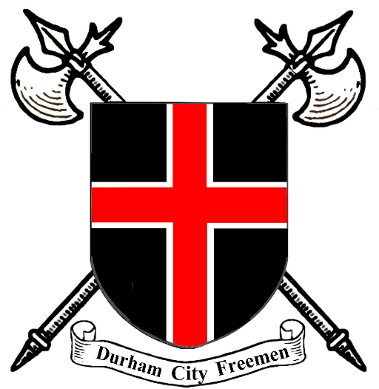

**Plumbers' Company**

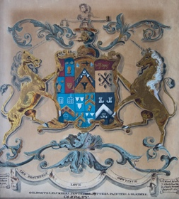

**The Initial Charter**

The Plumber’s Company was part of a coalition that included Goldsmiths, Pewterers, Potters and Painters whose Charter (Ordinary) was confirmed by Bishop Cuthbert Tunstall on 22May 1532.

Included within the rules of the Charter were the following;

Every year on Corpus Christi they shall every one of them go in procession with banner and lights and play or caused to be played the customary play at their own expense.

Every member, after being lawfully warned, shall attend every meeting, on penalty of 6d. to the bishop and 6d. To the craft, unless he can show a reasonable excuse.

He is to take no Scottish-born man as apprentice or workman. (20/-)

If one refuses to pay forfeits or duties, or will not swear obedience to the rules and ordinances before the steward of the borough court, complaint shall be made to the bishop’s chancellor, who shall compel the offender by imprisonment, if necessary, to do what he ought

No member shall attempt to get another man’s customers or work. (3/4)

On 3rd May 1660 the ordinary was again confirmed by Bishop Matthew, with a few additional rules that included:-

No man should be admitted to work in the city unless he was a good workman, and if he were not a member of the company he should not be allowed to remain for more than fourteen days.

**17 Century Freemen Plumbers**

**The Mensforths**

George Mensforth – Plumber Glazier of Durham

D.O.P. 1770

Will 18 June 1766 (DPR/1/1/1770/M5/1-2)

Reg. copy of Will 18/6/1766

(DPR/1/2/19/F27 V-28)

John Mensforth ( son of George Menforth)

Admitted as a Freeman to the Plumbers Company of the City of Durham and Framwellgate on 2nd November 1769



**The Brocketts**

William Brockett – D.O.P 1688

Bond 1688 (DPR/1/3/1688B154)

With transfers of administration (14/7/1688)

William Brockett the elder of North Bailey in Durham – D.O.P. 1693.

Inventory, total £19-5s-1p (31/3/1693)

With account, actual cost £19-5s-1p (with discharge £33-2s-1p

(DPR/1/1/1693/B6/1-2)

William Brockett, Plumber of South Bailey in or nigh the City of Durham D.O.P. 18th July 1707

Administration, penal sum £300 (DR/1/3/1707/£80/1-2)

William Brockett, Plumber of North Bailey

D.O.P. 15th May 1728

Will 25th February 1725 (DPR/1/11728/B10/1-2)

Registered copy of Will (DPR/1/1/12/PA60-461)

Will Bond penal sum £200, 15th May 1728 (DPR/1/3/1725/B74)

A meeting held on 3rd February 1708 found Cuthbert Hilton guilty of a high crime and misdemeanour in converting part of the money of the company to his own use, in particular the money in which he received for the reckoning at **Mrs. Elizabeth Brockett’s** house; and they fined him 6/8. He refused to pay and the warden was ordered to arrange for his arrest.

Goldsmiths Company entered in their minutes: “Remember that the head warden shall always pay his proportion to the expenses of drink to be expended on head meeting day.” Surtees suggested that the reason for this was the fact that **Brockett**, the warden, had decamped with £19 of the funds, so that till 1761 their finances were at very low ebb.

It is believed the Brockets, a family of Freemen Plumbers resided in the Baileys for almost a century

**The Bailey**

The names, North and South Bailey originated from the fortification of a motte and bailey castle by the Normans. The whole area within the loop of the River originally surrounded by fortification walls and the space between the inner and outer walls were known as baileys. The Bailey would therefore have been part of the defences on the City where day-to-day activities of the Castle would have taken place. There would have been living quarters for people associated with the Castle and Cathedral and would probably have housed stores, barracks, workshops, forges and stables.

  
  
It would appear that people living in the Bailey’s were of humble origins, connected to the workings of the Castle and Cathedral. As time passed, the properties were leased to professional people and by the 17th century, South Bailey became a fashionable place to live.

In a deed of 28th September 1691 whereby Nicholas Corby of Durham granted to William Brockett, a plumber of Durham and William Snowden a burrage in the North Bailey,(on the site now occupied by number 24). Where on the garden at the back they built a shop and workshop for their trade.

Most of the Baileys today are occupied by the University and/or the Cathedral.

**The Guild (Gild) of Plumbers in Medieval Durham**

In medieval time, , York, or London. For less important work anyone in the gild was basically into changeable as in: ‘a craftsman of the gild carried out whitewashing and other tasks’

Plumbers main occupation was, working with lead(Latin, plumbum for lead), this included roofing and leaded windows, but their main task was dealing with water and drainage. Technology at the time was borrowed from Roman engineering which was based on gravity flow and low pressure systems of channels and pipes to rivers and the sea.

Monks was scrupulously clean, washing their hands at the laver fountain before going into the refectory. The Durham Account Rolls, described women water carriers hauling water from the River Wear because the abbey’s pipes were frozen or fractured. Fountains were known as conduits or conduit houses and along with lavers were made of marble, tin, copper and zinc. Durham Abbey Accounts (1432-33) state that construction of a new laver required the services of several artisans. Expenses were for Lawrence the latoner (a Spout maker) and Thomas the plumber for installing pipes.

In the High Middle Ages, no branch of art was neglected and plumbers used their skills by introducing “shields of arms,fleur de lis and other devices for the enrichment of spires and pipes” which carried water from the roof.

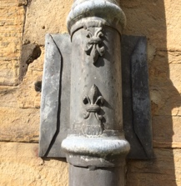

**17th Century River Wear Artefact**

**Incomplete Buckle**

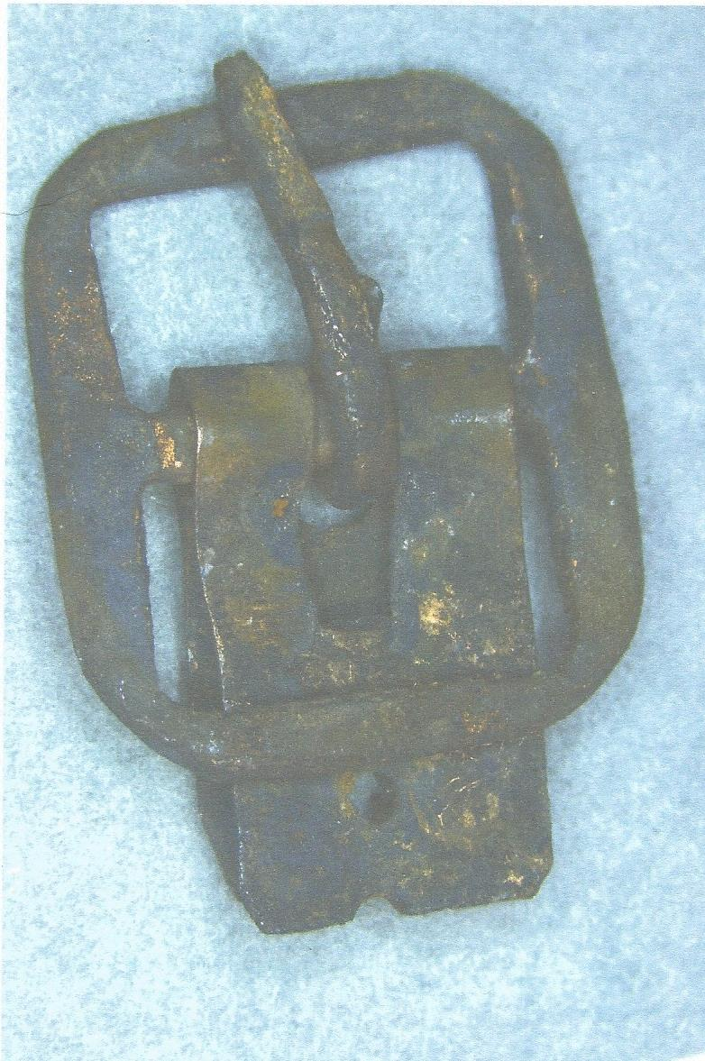

**Buckle**

Copper alloy buckle of post-mediaeval date, circa A.D. 1690-1720.The buckle is sub-rectangular with a drilled frame for a separate spindle. The corners are rounded and the frame is undecorated. A circular pin and stud chape remain around the spindle.

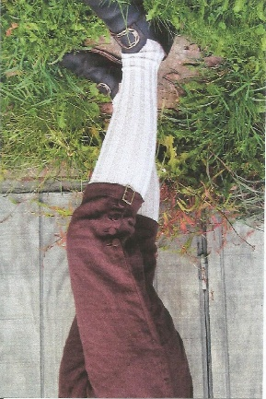The most common double buckle with a stud chape was used on the breeches, but because of the small size of earlier shoe buckles, they are difficult to tell apart



**Spatial Metadata**

* Region: North East England
* County: Durham
* Parish St Oswald  
    
  An underwater archaeological dive site located 30-40 metres downstream of Elvet Bridge.